Many animals are losing their habitats from human impact. This human impact can cause much danger for animals, like injuries, sickness or death; as well as destroying the habitat, causing them to leave and find a new place to go, but it can be very risky. The World Wildlife Fund (WWF) has been helping to stop all human impact in order to help the animals keep their habitat or find a new and safer place for them to stay. Animals like polar bears, living in the artic are close to becoming extinct from all the pollution causing global warming, melting the polar ice caps.
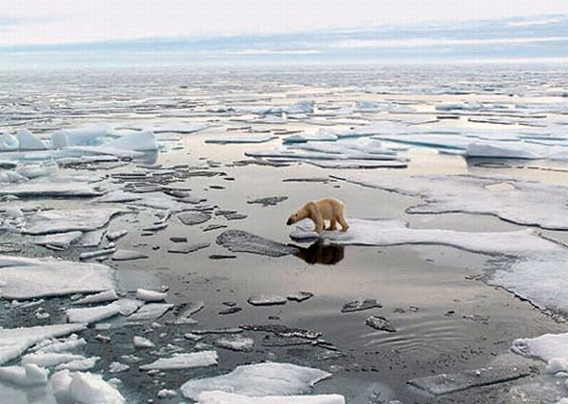
The picture to the right is of a polar bear trying to get a across the water using the ice to get across, but as you see most of it is melting, making it more difficult, difficult to get places, difficulties finding food. Polar bears can last a long time in water, but as they hunt for food and have cubs, this becomes more challenging as there are many threats towards the polar bears.
World Wildlife Fund is trying to help the polar bears, by making sure they are safe in their habitats, as they have polar bear trackers, knowing where they are at all times. You can help as well, just by donating or even adopting an animal, receiving a gift in return for doing so. You can also help by just being more eco-friendly in ways, it’s better by starting off small then doing nothing at all.

